**Computer**

**Network**

**Class Six**

**Lab 4**

|  |
| --- |
| Lab Objectives:Uses of network |

# Benefits of computer networks

## Setting up a computer network is a fast and reliable way of sharing information and resources within a business. It can help you to make the most opportunities of your IT systems and equipment.

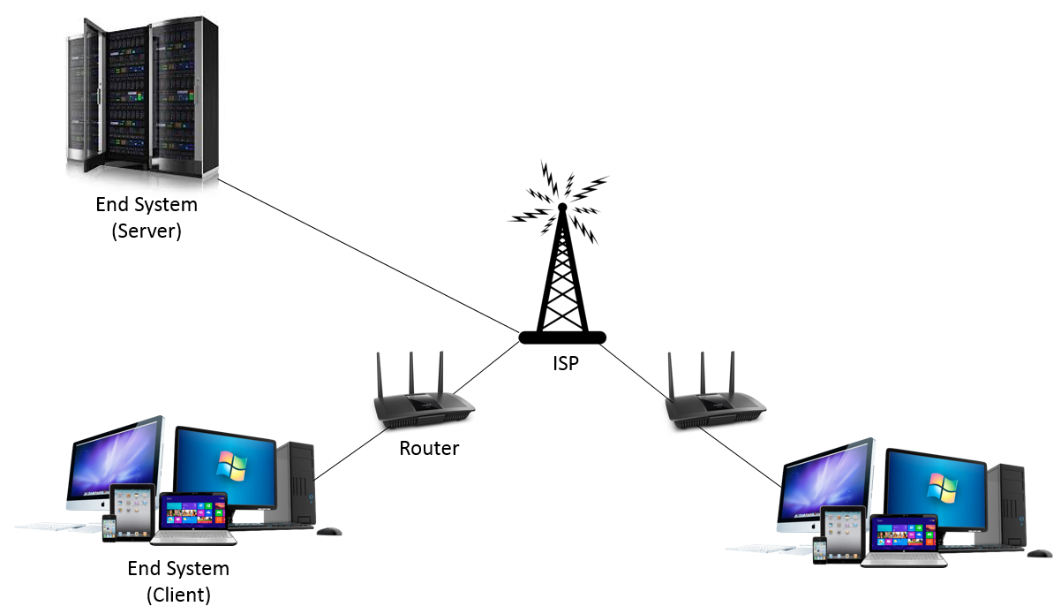

# Advantages of computer networking

## Main benefits of networks include:

## File sharing – you can easily share data between different users, or access it remotely if you keep it on other connected devices.



## Resource sharing – using network-connected peripheral devices like printers, scanners and copiers, or sharing software between multiple users, saves money.

## sharing

## IMG_256Sharing a single internet connection – it is cost-efficient and can help protect your systems if you properly secure the network.

## Increasing storage capacity – you can access files and multimedia,such as images and music, which you store remotely on other machines or network-attached storage devices.

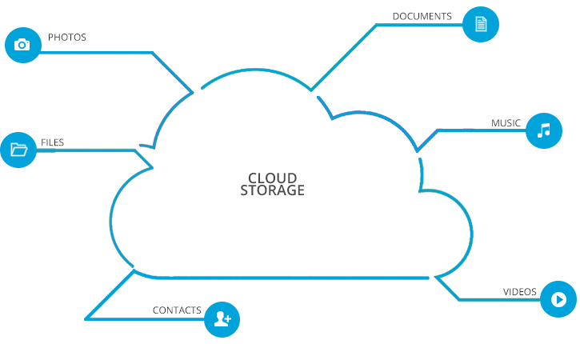

## 

## 

# Applications of Computer Networks

## A network is a collection or set of computing devices connected to one another to establish communication and also share available resources.

## A network will comprise software and hardware devices. You can have a network even if you are not connected to the internet.

### ****There are 2 types of network applications:-****

## Pure network applications

## Standalone network application

# Pure Network Applications

### Email Programs

## They allow users to type messages at their local nodes and then send to someone on the network.Examples of electronic mail programs (Clients) are:-

## Gmail

## IMG_256Outlook express

## Fox mail

## Opera

## Mozilla Thunderbird

## Windows mail

### File Transfer Protocol (FTP)

## This application facilities transfer of files from one computer to another e.g. from a client to a server. There are 2 common processes involved in FTP

## *Downloading:* - This is the process of obtaining files from a server to a workstation or a client (for example when you download programs and music from a server).

## *Uploading*:- This is obtaining of files from a workstation to a server (for instance when you attach documents and upload them to a server, a good example being when you upload photos to Facebook).

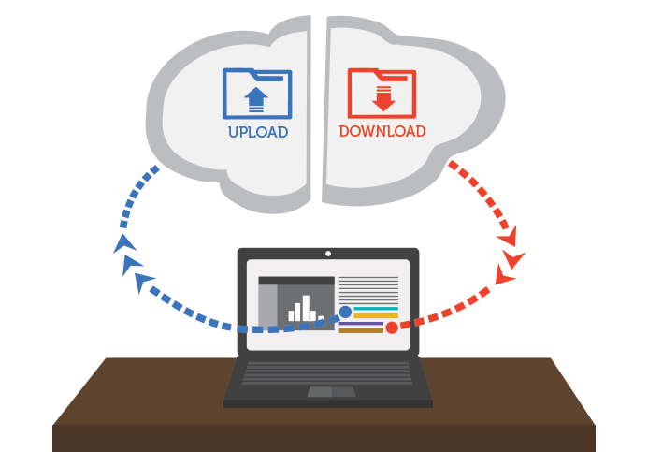

### 

### Groupware

## These applications can be used to communicate, co-operate, coordinate, solve problems, compete, negotiate among others.

## *(i) Video Conferencing*

## This is the process of conducting a conference between two or more participants at different sites by using computer networks to transmit audio and video data.



## (ii) Chatting

## It is real-time communication between two users via computer.



# (B) Stand Alone Applications

## These are applications that run on stand-alone computers (computers not connected to any other). In order to extend their activity, they are rebuilt to run on network environments e.g. word processors, spreadsheets, database management systems, presentations graphics, project management etc. They function even when the computer is offline.